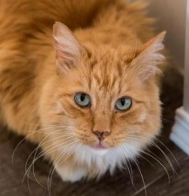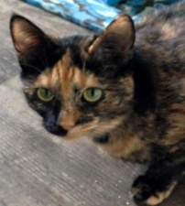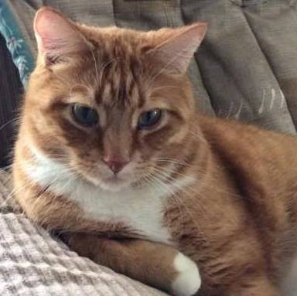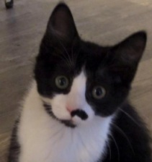

About the Cat You Would Like to Adopt

Are you interested in a particular cat? If yes, please provide the cat’s name.
What kind of cat would you prefer? Mark your preferences below with an X
Age  cat  kitten | Sex  male  female  either | Hair length  long medium  short  any length |  | Color  Do you prefer a certain color? | Personality Preferences – X all that apply
 |  |  |  |  |  | Affectionate |  | Independent
 |  |  |  |  |  | Lap-cat |  | Feisty
 |  |  |  |  |  | Shy and quiet |  | Playful
 |  |  |  |  |  | Bond with few |  | Companionable
 |  |  |  |  |  | Bond with  family |  | Good with dogs
Will your cat be:  Indoors & Free to roam house  other – please explain |  |  | Any other requests: |  |  | Good with shy  cats |  | Good with active  cats
 |  |  |  |  |  | A pet for my  pet |  | Mature, likes  routine
 |  |  |  |  |  | Ok in small  home |  | Athletic, on the go

About You (LCCR adoption applicants must be 18 years of age or older)

How many adults reside in your home? |  |  |  |  |  |  | Your age range: (please mark with an X)
 |  |  |  |  |  |  |  | 18 to 29 |  |  |  | 30 to 45 |  |  |  | 46 plus
If there are children in the home, what are their ages?
Does anyone smoke inside your house?
How long are you away from home on an average day? (please mark with an X)
 | Home all day |  |  |  |  | Out part-time |  |  |  |  |  |  |  | Away 8 to 10 hours
The following best describes our home atmosphere (please mark with an X)
 | Grand Central Station |  |  |  |  | Some Activity |  |  |  |  |  |  |  | Quiet and Serene
How would you rate your cat expertise and knowledge? (please mark with an X)
 | This is my first cat |  |  |  | I’ve had one or two |  |  |  |  |  |  |  | Experienced and knowledgeable
Please tell us about the companion cats you have owned in the last 10 years
Cats’ name(s) |  | Age |  | Cause of death |  |  |  |  | If not deceased what became of them?
Have you adopted before?

About Your Current Companion Animals

Please list other pets in your home.
What are their names and ages?
Have they had experience living with other cats? (please mark with an X)
 |  | yes |  |  |  | No |  |  |  |  | Don’t know
Are their vaccinations up to date?

Are they spayed/neutered?
Name of your current veterinary clinic.

Are there any topics you would like to discuss with an Adoption Coordinator? (please mark with an X)
Other Questions-
 | One cat or two? |  |  | Vaccines |  |  |  | Litter box training |  |  |  | Safe Cleaners/ Chemicals
 | Indoor vs Outdoor |  |  | Diet |  |  |  | Cats and kids |  |  |  | Cat licensing/identification
 | Scratching furniture |  |  | Declawing |  |  |  | Allergies |  |  |  | Cat versus kitten
 | Introductions to other pets |  |  | Vacations with /  without pets |  |  |  | Moving with /  without pets |  |  |  | Cats escaping & getting lost

Your Contact Information

Name (s) | Date
Address | Email address
City & Province | Home phone
Postal code | Cell phone
Do you own or rent your home? | Work phone
Does your landlord allow pets? | Landlord Name and Phone Number
Personal Reference- Name-
(not family) Phone Number-
How did you hear about The Last Chance Cat Ranch?

Please note: By signing and submitting this application, you are giving The Last Chance Cat Ranch permission to verify your information by contacting the veterinary clinic, landlord and reference you have noted above. If signing this via an online/ email application, your typed name is considered your legal binding signature.

Signature of Applicant Date signed

Please email your completed application to thelccr@gmail.com

